

**Software Requirement Specification (SRS)**

Of

**Counselling module**

For Implementation of

**Campus Management Software**

at

**World Skill Center (WSC)**

**Sustainable Outreach And Universal**

**Leadership (SOUL) Limited**

**Sustainable Outreach And Universal**

**Leadership (SOUL) Limited**

**Table of Content**

A. Abstract 3

B. Introduction 3

C. Definition, Acronyms and Abbreviations 3

D. Overview of the Document 3

E. Scope of Education Module 4

F. WSC Student Counselling Process Flow 5

G. Process Flow Description 6

H. List of Screens and Their Descriptions : 6

I. Counselling & Entrance Exams 8

1. Home Screen: 8

1.1. Counselling Structure 8

1.2. Student Admission 11

1.3. Student Applicant 16

1.4. Center Selection Master 27

1.5. Entrance Exam Declaration 28

1.6. Entrance Exam Center Allocation 31

1.7. Admit Card Generation Tool 34

1.8. Entrance Exam Admit Card 37

1.9. Entrance Exam Result Publication 38

1.10. Rank Card Publication Masters 39

1.11. Rank Card 41

1.12. Rank Card Publication Tool 44

1.13. Program Enrolment 46

# Abstract

Software Requirements Gathering is one of the first phases of system development. This phase results in the Software Requirements Specification (SRS) document, which must contain a complete, concise, high-quality description of the system being considered.

# Introduction

The World Skill Center (WSC) is a premier advanced skill training institute established by the Government of Odisha, Skill Development and Technical Education Department, through the Odisha Skill Development Authority (OSDA). The WSC will impart advanced skill training in eight trades from engineering and service sectors. WSC caters primarily to induct the best talent from ITIs and Polytechnics and train them to become globally employable in emerging areas such as "Industry 4.0". WSC is housed in a state-of-the-art, 18-storey, air-conditioned building with nearly half a million square feet of space in the heart of capital city of Bhubaneswar.

With the Implementation of campus management software for WSC the goal is to streamline the operations and functions of the campus by integrating various processes, such as admissions, course registration, academic progress tracking, and financial management, HRMS, Procurement and Inventory management, etc into a unified system. The implementation also aims at providing a user-friendly interface for all stakeholders, making it easier for them to access the necessary information and complete their tasks with ease. The modules to be covered during the implementation of the software includes:

|  |  |
| --- | --- |
| Students Management Modules | Infrastructure Management |
| Academic System | Finance and Accounting System |
| Procurement & Inventory Management | Training and Placement |
| Human Resources Management System | Application Integration |

# Definition, Acronyms and Abbreviations

The following table explains the terms and abbreviations used in the document:

|  |  |
| --- | --- |
| **Abbreviation** | **Description** |
| SRS | Software Requirements Specification |
| SLCM | Student Life Cycle Management |
| R | Rename - When a field is Renamed |
| N | New - When a New field is Added |
| D | Delete - When an Existing field is Deleted |
| NA | Not Applicable |

# Overview of the Document

This requirement document provides a detailed overview of the functional requirements of a project. It serves as a communication tool between stakeholders, including developers, project managers, and end-users. The purpose of this requirement document is to define and document the project's objectives, scope, and expectations, and to ensure that all stakeholders have a clear understanding of what the project entails.

This document covers all the functional requirements of the **Entrance Exam & Counselling module** of ERP Product. This helps in organizing the education set-up, such as Student Database, Student Application Form, Applicant Entrance Examination, Document Verification, Course Selection, Seat Booking, Fee Management etc.

# Scope of Education Module

* Courses and Subjects, Timetable preparation and management  ▪
* Class occurrence monitoring
* Class Attendance of students (Face recognition or any other automated mode).    ▪
* Results Analysis after declaration of results by WSC ▪
* Students Feedback mechanism on quality of teaching learning ▪ Internship, Training, Apprentice ▪
* Re-Admission Process after discontinuing in studies ▪
* Students Back paper tracking etc.
* Students Profile.  :Personal Information, Contact Details, Academic Details ▪
* Issue of Identity Card.  ▪
* Students Profile: Personal Information, Contact Details, Academic Details.
* Re-Admission Process after discontinuing in studies
* Issue of Identity Card
* Faculty Workload / Lesson Plan
* Rewards and achievements. 
* Biometric Attendance (Face recognition) ▪
* Hostel Management (Hostel seat allotment, attendance, fees etc) ▪
* Scholarships.  ▪
* Results Analysis after declaration of results by WSC ▪
* Students Back paper tracking etc.
* Students Exams records ▪
* Alert/Messaging Management. 
* Rewards and achievements.  ▪
* Students’ Evaluation/remarks of Faculty.  ▪
* Students Exams records of all 6 semesters ▪
* Parent Enquiry/Alert/Messaging Management.  ▪
* Messaging System  ▪
* Students Grievance System etc.

Following functionalities are covered in this SRS document:

* **Student Application Form**
* **Entrance Exam Declaration**
* **Applicant Admit Card Generation**
* **Entrance Exam Result Publication**
* **Rank Generation**
* **Counselling Structure**

# WSC Student Counselling Process Flow

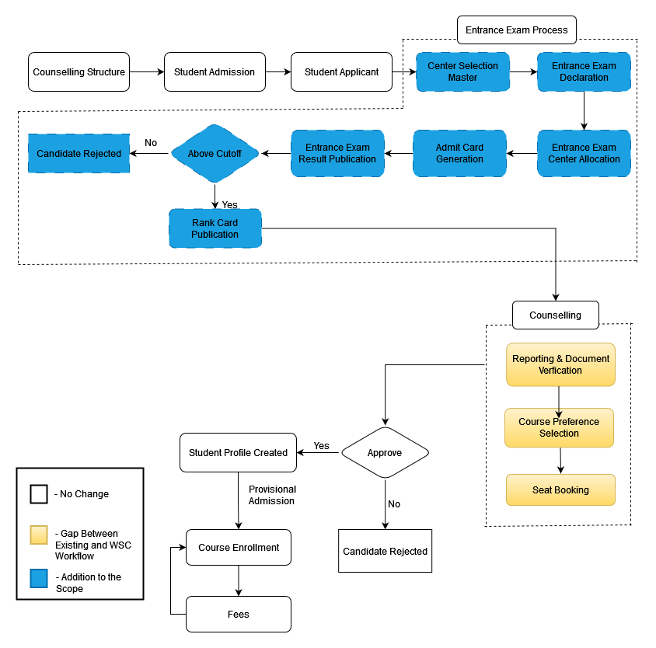

# **Process Flow Description**

**Student Admission**

Student Admission Card represents the Admission configuration for different courses, regarding their eligibility criteria, documents requirement, Counselling Structure, etc.

**Center Selection Master**

Center Selection Master represents the exam center information, its address details and total capacity

**Student Applicant**

Student Applicant Card contains the application form by which students can apply for their respective courses for getting admission.

**Entrance Exam Declaration**

Entrance Exam Declaration card contains the details for declaring entrance exam for the student applicants.

**Admit Card**

Admit card contains the details of individuals student applicants records such as their exam data, time, venue, course details, etc.

**Entrance Exam Result Publication**

Entrance Exam Evaluation process includes the result publish process of every student applicants who had applied for Entrance Examination.

**Rank Card Publication**

Rank Card Publication card represents the process of giving ranks to the eligible student applicants for admission.

**Counselling Structure**

A screen used for setting up counselling eligibility , marks cutoff , programs for which counselling will be held and document needed for an upcoming counselling session .

**Student**

After approval of Student applicants, Student screen is created where all the general details of individual students are present.

**Course Enrollment**

Course Enrollment is the record of enrollment of a student in a given program and chosen courses for a particular Academic Term.

# **List of Screens and Their Descriptions :**

|  |  |  |
| --- | --- | --- |
| Prerequisite screens Required for Entrance Exam & Counselling | | |
| **ID** | **Screen Name** | **Description** |
|  | Department | A Department is a specialized functional area or a division within an organization. |
|  | Programs | A program will have an educational curriculum defined by user institute to streamline the learning process and goals in each subject or module. |
|  | Course | A Course can be considered as a subject or a part of an educational program which is to be taught for a term |
|  | Academic Year | An academic year is a period which the Educational Institutes, Schools and Universities use to measure a quantity of study. |
|  | Academic Term | An Academic Term would become a part of the Academic Year, during which the Institute will assess its students on the curriculum defined for that term. |
|  | Document Template | Document template contains the documents name needed with respect to different courses for different academic years. |
|  | Academic Calendar | Academic Calendar contains the different events for a particular year for every individual courses. |
|  | Student Admission | Student Admission is a document which can be configured to initiate an admission Process for user by publishing it on the Institute website. |
|  | Student Applicant | **A Student Applicant record gets created when a student applies to your institute for admission.** |
|  | Program Enrollment | Program Enrollment is the record of enrollment of a student in a given program and chosen courses for a particular Academic Term. |
|  | Student | The Student document will hold all the data related to the students. |
|  | Employee | A person working under WSC, as per need any employee could be assigned as an invigilator to the entrance exam and as such sent to the specific location during the entrance exams |
|  | Student Category | Student Category is based upon the castes of the students such as ST, SC, General, Etc. |
|  | Fee Category | Fee Category would form all the components for calculation of Fees or creation of Fee Structure. |
|  | Fee Structure | A Fee Structure is a template that can be used while making Fees records or generating them via the Fee Schedule. |
|  | Fee Schedule | Fee Schedule would help in defining a time-line for the Fee payment of the students, based on the Student Group. |
|  | Fees | Every individual students Fee Records are maintained in the Fees screen |
| **Screens for Entrance Exam & Counselling** | | |
| ID | Screen Name | Description |
|  | Counselling Structure | A screen used for setting up counselling eligibility , marks cutoff , programs for which counselling will be held and document needed for an upcoming counselling session . |
|  | Center Selection Master | A master screen where basic information regarding a exam centre is stored |
|  | Entrance Exam Declaration | Entrance Exam Declaration is **where information regarding exams are stored , like exam date, academic year , term and applicants list** |
|  | Admit card Generation Tool | **A screen to generate multiple admit cards for applicants and also allot them a venue and date for the exam** |
|  | Entrance Exam Admit Card | Entrance Exam Admit Card **contains information of an individual students admit card details** |
|  | Entrance Exam Result Publication | **A screen which contains the marks of an applicant for the entrance exams** |
|  | Rank Card Publication Master |  |
|  | Rank Card Publication Tool | **A screen which used to make large number of rank card** |
|  | Rank Card | **A screen which contains the information regarding an applicants rank obtain in the entrance exam** |

# **Counselling & Entrance Exams**

## Home Screen:

This is the Homepage for the logged in User.

Figure 1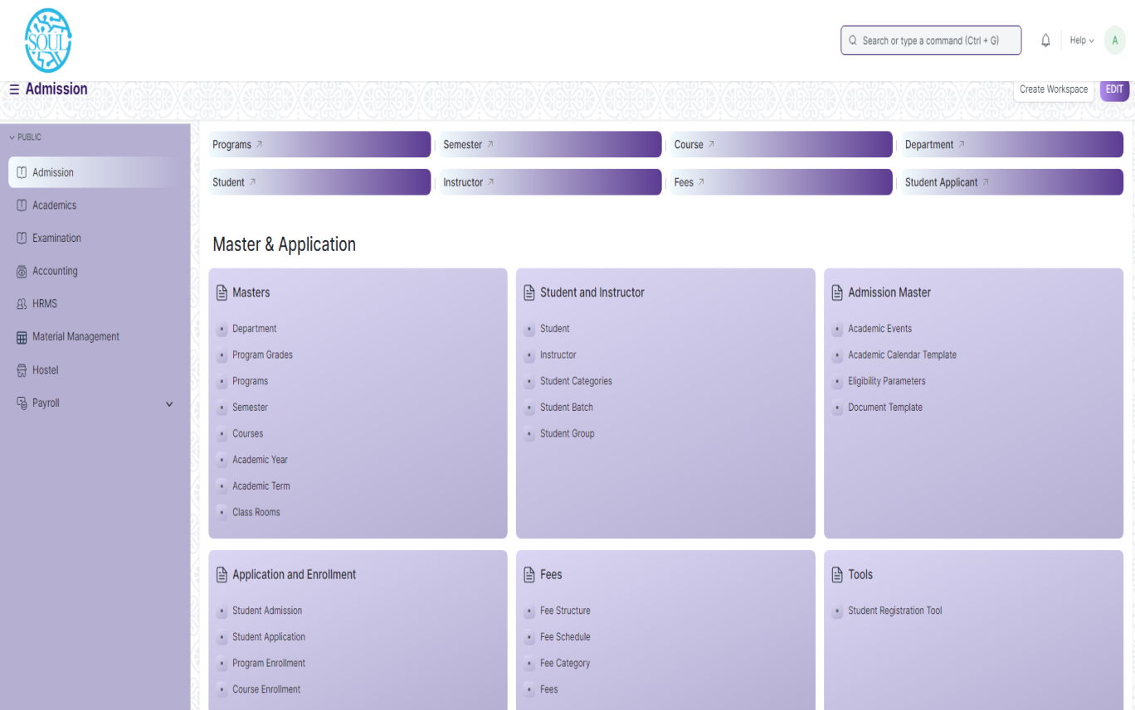: Home Screen

## 1.1. Counselling Structure

**General Description:**

The following table describe overall information about this screen

|  |  |
| --- | --- |
| **Description :** | * A screen used for setting up counselling eligibility , marks cutoff , programs for which counselling will be held and document needed for an upcoming counselling session . |
| **Navigation :** | Home > Admission > Counselling > Counselling Structure |
| **Pre-requisites :** | The system should have records in the following screen   1. Academic Year 2. Programs 3. Departments 4. Student Category 5. Document Template |
| **Existing Screen Name** | Counselling Structure |
| **New Screen Name** | No change |

**Screenshot:**

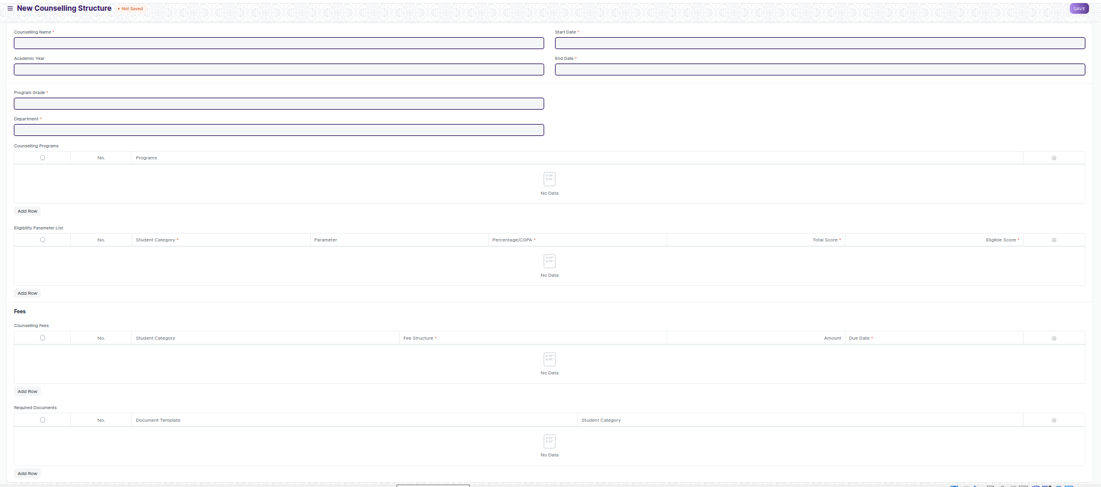

Figure 2: Counselling Structure

**Field List:**

The following table describes the UI fields present in this screen :

|  |  |  |  |  |  |  |
| --- | --- | --- | --- | --- | --- | --- |
| **ID** | **Field Name** | **Field Type** | **Mandatory** | **Validation/Action** | **Remarks** | **R/N/D** |
| 1 | Counselling Name | Text Field | Yes |  |  |  |
| 2 | Academic Year | Link Field |  | Links to Master Screen Academic Year |  |  |
| 3 | Start Date | Date | Yes |  |  |  |
| 4 | End Date | Date | Yes |  |  |  |
| 5 | Program Grade | Link Field | Yes | Links to Master Screen Program Grade | Not Applicable for Admission Module |  |
| 6 | Department | Link Field | Yes | Links to Master Screen Department |  |  |
| 7 | **Counselling Programs** | Table |  |  | For further details regarding table Please check below |  |
| 8 | **Eligibility Parameter List** | Table |  |  | For further details regarding table Please check below |  |
| 9 | **Counselling Fees** | Table |  |  | For further details regarding table Please check below |  |
| 10 | **Required Documents** | Table |  |  | For further details regarding table Please check below |  |

|  |  |  |  |  |  |  |
| --- | --- | --- | --- | --- | --- | --- |
| **Counselling Programs** | | | | | | |
| **ID** | **Field Name** | **Field Type** | **Mandatory** | **Validation/Action** | **Remarks** | **R/N/D** |
| 1 | Programs | Link Field | Yes | Link Fields to Programs Master screen |  |  |

|  |  |  |  |  |  |  |
| --- | --- | --- | --- | --- | --- | --- |
| **Eligibility Parameter List** | | | | | | |
| **ID** | **Field Name** | **Field Type** | **Mandatory** | **Validation/Action** | **Remarks** | **R/N/D** |
| 1 | Student Category | Link Field | Yes | Link Fields to Student Category master screen |  |  |
| 2 | Parameter | Link Field |  | Links to Eligibility Parameter Master Screen |  |  |
| 3 | Percentage/CGPA | Dropdown | Yes | Its option includes, Percentage & CGPA |  |  |
| 4 | Total Score | Number | Yes |  |  |  |
| 5 | Eligible Score | Number | Yes |  |  |  |

|  |  |  |  |  |  |  |
| --- | --- | --- | --- | --- | --- | --- |
| **Counselling Fees** | | | | | | |
| **ID** | **Field Name** | **Field Type** | **Mandatory** | **Validation/Action** | **Remarks** | **R/N/D** |
| 1 | Student Category | Link Field | Yes | Link Fields to Student Category master screen |  |  |
| 2 | Fee Structure | Link Field | Yes | Links to Fee Structure Master Screen |  |  |
| 3 | Amount | Number | Yes |  |  |  |
| 4 | Due Date | Date | Yes |  |  |  |

|  |  |  |  |  |  |  |
| --- | --- | --- | --- | --- | --- | --- |
| **Required Documents** | | | | | | |
| **ID** | **Field Name** | **Field Type** | **Mandatory** | **Validation/Action** | **Remarks** | **R/N/D** |
| 1 | Document Template | Link Field | Yes | Links to Document Template Screen |  |  |
| 2 | Student Category | Link Field | Yes | Link Fields to Student Category master screen |  |  |

**User: Roles & Permission**

The following table describes the users and their roles and permissions for the screens:

|  |  |  |  |  |  |  |  |  |  |
| --- | --- | --- | --- | --- | --- | --- | --- | --- | --- |
| **ID** | **Role** | **Select** | **Read** | **Write** | **Create** | **Delete** | **Submit** | **Cancel** | **Amend** |
| 1 | Admin | Yes | Yes | Yes | Yes | Yes | NA | NA | NA |
| 2 | Instructor | Yes | Yes | No | No | No | NA | NA | NA |
| 3 | Education Admin | Yes | Yes | Yes | Yes | Yes | NA | NA | NA |

## 1.2. Student Admission

**General Description :**

The following table describe overall information about this screen

|  |  |
| --- | --- |
| **Description :** | * Student Admission is a document which can be configured to initiate an Admission Process |
| **Navigation :** | Home > Admission > Application And Enrollment > Student Admission |
| **Pre-requisites :** | The system should have records in the following screen   1. Academic Calendar 2. Academic Year 3. Academic Term 4. Admission Program 5. Semester |
| **Existing Screen Name** | Student Admission |
| **New Screen Name** | No change |

**Screenshot:**

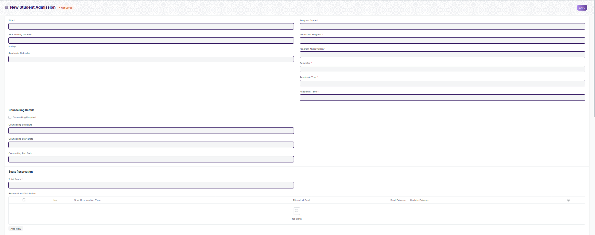

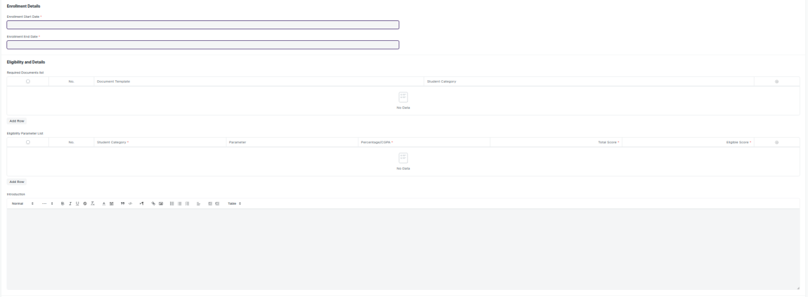

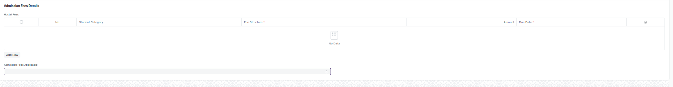

Figure 3: Student Admission

**Field List:**

The following table describes the UI fields present in this screen:

|  |  |  |  |  |  |  |
| --- | --- | --- | --- | --- | --- | --- |
| **ID** | **Field Name** | **Field Type** | **Mandatory** | **Validation/Action** | **Remarks** | **R/N/D** |
| 1 | Title | Text | Yes |  |  |  |
| 2 | Seat holding duration | Number |  |  |  |  |
| 3 | Academic Calendar | Link Field |  | Link Fields to master screen Academic Calendar |  |  |
| 4 | Program Grade | Link Field |  | Link Fields to master screen Program Grade |  | ( R ) Course Grade |
| 5 | Admission Program | Link Field | Yes | Link Fields to master screen Programs and need to be filtered on the basis of Program Grade |  | ( R ) Admission Course |
| 6 | Program Abbreviation | Text | Yes |  |  | ( R ) Course Abbreviation |
| 7 | Semester | Link Field | Yes | Link Fields to master screen Semester and need to be filtered on the basis of Programs |  |  |
| 8 | Academic Year | Link Field | Yes | Link Fields to master screen Academic Year |  |  |
| 9 | Academic Term | Link Field | Yes | Link Fields to master screen Academic Term, and need to be filtered on the basis of Academic Year |  |  |
| 10 | Counselling Required | Checkbox |  | If Checked then counselling Structure field will be mandatory |  |  |
| 11 | Counselling Structure | Link Field |  | Link Fields to master screen Counselling Structure |  |  |
| 12 | Counselling Start Date | Date |  | Start date need to be before End date |  |  |
| 13 | Counselling End Date | Date |  | End date need to be greater then start date |  |  |
| 14 | Admission Start Date | Date |  | Start date need to be before End date |  |  |
| 15 | Admission End Date | Date |  | End date need to be greater then start date |  |  |
| 16 | Total Seats | Number | Yes |  |  |  |
| 17 | Reservations Distribution | Child Table |  | Description of child table is in below |  |  |
| 18 | Enable Admission Application | Checkbox |  |  |  |  |
| 19 | Enrollment Start Date | Date | Yes | Start date need to be before End date |  |  |
| 20 | Enrollment End Date | Date | Yes | End date need to be greater then start date |  |  |
| 21 | **Eligibility and Details** | Table |  | Description of child table is in below |  |  |
| 22 | **Required Documents list** | Table |  | Description of child table is in below |  |  |
| 23 | **Eligibility Parameter List** | Table |  | Description of child table is in below |  |  |
| 24 | **Hostel Fees** | Table |  | Description of child table is in below |  |  |
| 25 | Counselling Fees Applicable | Dropdown |  | Yes  No |  |  |
| 26 | Admission Fees Applicable | Dropdown |  | Yes  No |  |  |
| 27 | **Admission Fee Structure** | Table |  | Table will be visible when user entered Yes in Admission Fees Applicable dropdown |  |  |

|  |  |  |  |  |  |  |
| --- | --- | --- | --- | --- | --- | --- |
| **Reservations List** | | | | | | |
| **ID** | **Field Name** | **Field Type** | **Mandatory** | **Validation/Action** | **Remarks** | **R/N/D** |
| 1 | Seat Reservation Type | Link Field |  | Link Field to Seat Reservation Type Screen | Link Fields to Seat Reservation Type screen |  |
| 2 | Allocated Seat | Number |  |  |  |  |
| 3 | Seat Balance | Number |  |  |  |  |
| 4 | Update Balance | Button |  | Button Description is in below |  |  |

|  |  |  |  |  |  |  |
| --- | --- | --- | --- | --- | --- | --- |
| **Update Balance (popup)** | | | | | | |
| **ID** | **Field Name** | **Field Type** | **Mandatory** | **Validation/Action** | **Remarks** | **R/N/D** |
| 1 | Type | Dropdown |  | Add Balance  Deduct Balance |  |  |
| 2 | No. Of Seat | Number |  |  |  |  |
| 3 | Update | Button |  | On click of Update button **no. of seat** field value will be updated with respect to **Type** field i.e., Add Balance and Deduct Balance options. | Need to be Auto Update d when Program Enrollment record Submitted or Cancelled. |  |

|  |  |  |  |  |  |  |
| --- | --- | --- | --- | --- | --- | --- |
| **Student Admission Program** | | | | | | |
| **ID** | **Field Name** | **Field Type** | **Mandatory** | **Validation/Action** | **Remarks** | **R/N/D** |
| 1 | Programs | Link Field |  | Link Fields to programs screen |  | Course |
| 2 | program | Link Field |  | Link Fields to semester screen |  | Semester |
| 3 | min_age | Number |  | Min_age should not be less then 0 |  |  |
| 4 | max_age | Number |  | Min_age should not be greater then 35 |  |  |
| 5 | description | Small Text |  |  |  |  |
| 6 | application_fee | Currency |  |  |  |  |
| 7 | applicant_naming_series | Text |  |  |  |  |

|  |  |  |  |  |  |  |
| --- | --- | --- | --- | --- | --- | --- |
| **Required Documents** | | | | | | |
| **ID** | **Field Name** | **Field Type** | **Mandatory** | **Validation/Action** | **Remarks** | **R/N/D** |
| 1 | Document Template | Link Field |  | Link Fields to master screen Document Template |  |  |
| 2 | Student Category | Link Field |  | Auto fetch the student category when document template entered |  |  |

|  |  |  |  |  |  |  |
| --- | --- | --- | --- | --- | --- | --- |
| **Eligibility Parameter List** | | | | | | |
| **ID** | **Field Name** | **Field Type** | **Mandatory** | **Validation/Action** | **Remarks** | **R/N/D** |
| 1 | Student Category | Link Field | Yes | Link Fields to master screen Student Category |  |  |
| 2 | Parameter | Link Field |  | Link Fields to master screen Eligibility Parameters |  |  |
| 3 | Percentage/CGPA | Dropdown | Yes |  |  |  |
| 4 | Total Score | Float | Yes |  |  |  |
| 5 | Eligible Score | Float | Yes |  |  |  |

|  |  |  |  |  |  |  |
| --- | --- | --- | --- | --- | --- | --- |
| **Fee Structure Item** | | | | | | |
| **ID** | **Field Name** | **Field Type** | **Mandatory** | **Validation/Action** | **Remarks** | **R/N/D** |
| 1 | Student Category | Link Field |  | Link Fields to Student Category screen |  |  |
| 2 | Fee Structure | Link Field | Yes | Link Fields to Fee Structure screen |  |  |
| 3 | Amount | Currency |  |  |  |  |
| 4 | Due Date | Date | Yes |  |  |  |

**User Roles & Permission**

The following table describes the users and their roles and permissions for the screens :

|  |  |  |  |  |  |  |  |  |  |
| --- | --- | --- | --- | --- | --- | --- | --- | --- | --- |
| **ID** | **Role** | **Select** | **Read** | **Write** | **Create** | **Delete** | **Submit** | **Cancel** | **Amend** |
| 1 | Admin | Yes | Yes | Yes | Yes | Yes | NA | NA | NA |
| 2 | Instructor | Yes | Yes | No | No | No | NA | NA | NA |
| 3 | Education Admin | Yes | Yes | Yes | Yes | Yes | NA | NA | NA |

## **1.3. Student Applicant**

**General Description:**

The following table describe overall information about this screen

|  |  |
| --- | --- |
| **Description :** | * Student Applicant is a form is used by an applicant to fill the necessary details regarding admission |
| **Navigation :** | Home > Admission > Application And Enrolment > Student Applicant |
| **Pre-requisites :** | The system should have records in the following screen  1. Academic Calendar  2. Academic Year  3. Academic Term  4. Student Category  5.Department  6.Program Grade |
| **Existing Screen Name** | Student Applicant |
| **New Screen Name** | No change |

**Screenshots:**

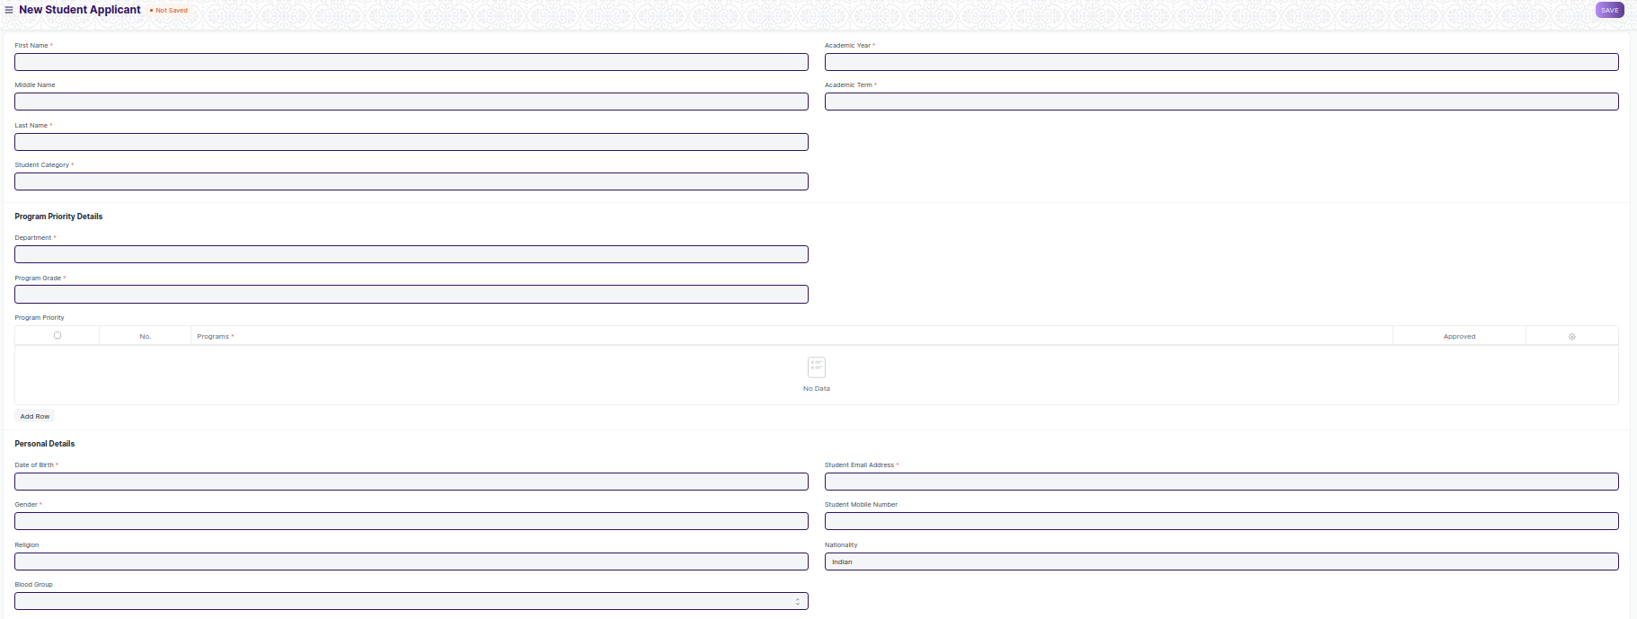

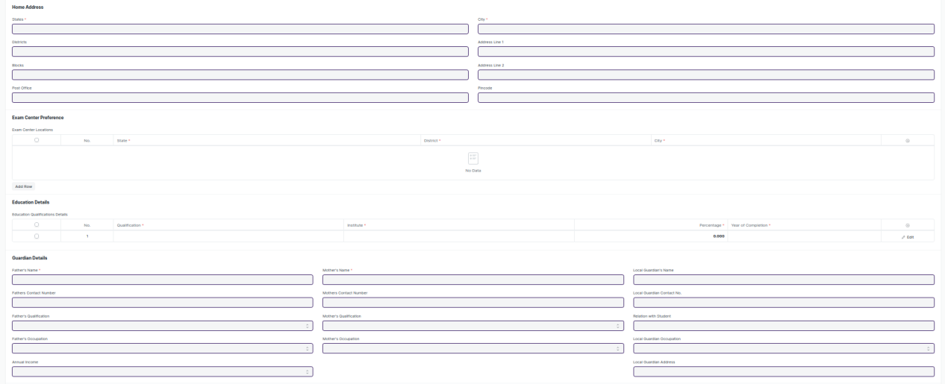

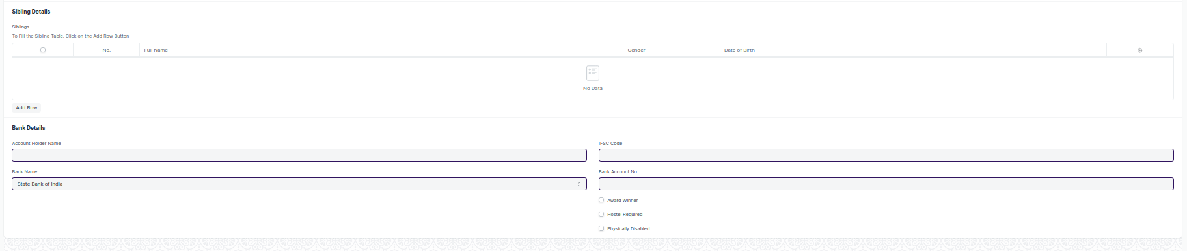

Figure 4: Student Applicant

**Field List:**

The following table describes the UI fields present in this screen:

|  |  |  |  |  |  |  |
| --- | --- | --- | --- | --- | --- | --- |
| **ID** | **Field Name** | **Field Type** | **Mandatory** | **Validation/Action** | **Remarks** | **R/N/D** |
| 1 | First Name | Text Field | Yes |  |  |  |
| 2 | Middle Name | Text Field | No |  |  |  |
| 3 | Last Name | Text Field | Yes |  |  |  |
| 4 | Academic Year | Link Field | Yes | Links to Master Screen Academic Year |  |  |
| 5 | Academic Term | Link Field | Yes | Links to Master Screen Academic Term |  |  |
| 6 | Student Category | Link | Yes | Links to Master Student Category |  |  |
| 7 | Physically Disabled | Checkbox |  |  |  |  |
| **8** | **Physically Disabled** | Table |  | Appears Only if Physical Disability Checkbox is clicked | For further details regarding table Please check below |  |
| 9 | Hostel Required | Checkbox |  |  |  |  |
| 10 | Room Type | Link Field |  | Appears only if Hostel Required Checkbox is clicked |  |  |
| 11 | Sharing | Dropdown |  | Contains options regarding no. of residents in the room |  |  |
| 12 | Award Winner | Checkbox |  |  |  |  |
| 13 | **Awards List** | Table |  | Appears only if Award Winner Required Checkbox is clicked | For further details regarding table Please check below |  |
| 14 | Program Grade | Link Field |  | Links to Program Grade | Not Applicable for Admission Module |  |
| 15 | Department | Link Field | Yes | Link to Department |  |  |
| 16 | **Program Priority** | Table |  |  | For further details regarding table Please check below |  |
| 17 | **Student Rank List** | Table |  | After rank card distribution, applicants General Ranks will be visible here |  | N |
| 19 | **Rank Based Program Priority** | Table |  | A hidden table that will appear after ranks have been declared and applicants will need to fill this table on basis of their ranks | For further details regarding table Please check below | N |
| 20 | Counselling Start | Checkbox |  | This checkbox only be accessible to Admins and when its checked the counselling based program priority child table will be appear |  | N |
| 20 | **Counselling Based Program Priority** | Table |  | A hidden table that will appear during counselling ,when student has reported to the venue and has gone through documents verification then student will be asked to provide course preference as per availability.On the basis of this table program enrollment will take place | For further details regarding table Please check below | N |
| 21 | Date of Birth | Text Field | Yes |  |  |  |
| 22 | Student Email Address | Text Field | Yes |  |  |  |
| 23 | Gender | Link Field | Yes | Links to Master Screen Genders |  |  |
| 24 | Student Mobile Number | Number |  |  |  |  |
| 25 | Religion | Link Field |  | Links to Religion Master Screen |  |  |
| 26 | Nationality | Text Field |  |  |  |  |
| 27 | Blood Group | Dropdown |  |  |  |  |
| 28 | States | Link Field | Yes | Links to States Master Screen |  |  |
| 29 | Districts | Link Field | Yes | Links to Districts Master Screen and filtered applied with respect to State |  |  |
| 30 | Blocks | Link Field | Yes | Links to Blocks Master Screen and filtered applied with respect to Districts |  |  |
| 31 | Post Office | Text Field |  |  |  |  |
| 32 | City | Text Field | Yes |  |  | (R) City/ Village / Town |
| 33 | Address Line 1 | Text Field |  |  |  |  |
| 34 | Address Line 2 | Text Field |  |  |  |  |
| 35 | Pincode | Text Field | Yes |  |  |  |
| 36 | **Exam Center Preferences** | Table | Yes |  | For further details regarding table Please check below | N |
| 37 | **Documents Required** | Table |  | In this table another column needs to added called Verified. In the columns a checkbox will be present that will be ticked only after physical verification of the candidates documents. This field will only be visible to the instructors or admins | For further details regarding table Please check below |  |
| 38 | **Education Qualifications Details** | Table | Yes | After entering the program priorities, Education Qualifications Details can only be filled | For further details regarding table Please check below |  |
| 39 | Father’s Name | Text Field | Yes |  |  |  |
| 40 | Father’s Contact Number | Text Field |  |  |  |  |
| 41 | Father’s Qualification | Dropdown |  |  |  |  |
| 42 | Father’s Occupation | Dropdown |  |  |  |  |
| 43 | Father’s Annual Income | Dropdown |  |  |  |  |
| 44 | Mother’s Name | Text Field | Yes |  |  |  |
| 45 | Mother’s Contact Number | Text Field |  |  |  |  |
| 46 | Mother’s Qualification | Dropdown |  |  |  |  |
| 47 | Mother’s Occupation | Dropdown |  |  |  |  |
| 48 | Local Guardian’s Name | Text Field |  |  |  |  |
| 49 | Local Guardian’s Contact Number | Text Field |  |  |  |  |
| 50 | Relation with Student | Text Field |  |  |  |  |
| 51 | Local Guardian’s Occupation | Dropdown |  |  |  |  |
| 52 | Local Guardian’s Address | Text Field |  |  |  |  |
| 53 | **Siblings Details** | Table |  |  | For further details regarding table Please check below |  |
| 54 | Account Holder Name | Text Field |  |  |  |  |
| 55 | IFSC Code | Text Field |  |  |  |  |
| 56 | Bank Name | Dropdown |  |  |  |  |
| 57 | Bank Account Number | Text Field |  |  |  |  |
| 58 | Total Counselling Fees | Number |  |  |  |  |
| 59 | **Admission Fees** | Table |  |  | For further details regarding table Please check below |  |

|  |  |  |  |  |  |  |
| --- | --- | --- | --- | --- | --- | --- |
| **Physically Disabled** | | | | | | |
| **ID** | **Field Name** | **Field Type** | **Validation/Action** | **Mandatory** | **Remarks** | **R/N/D** |
| 1 | Disability Type | Text Field |  |  |  |  |
| 2 | Percentage of Disability | Number |  |  |  |  |
| 3 | Attach Disability Certificate Attach | Attach |  |  |  |  |
| 4 | Disability Type | Text Field |  |  |  |  |

|  |  |  |  |  |  |  |
| --- | --- | --- | --- | --- | --- | --- |
| **Student Rank List** | | | | | | |
| **ID** | **Field Name** | **Field Type** | **Validation/Action** | **Mandatory** | **Remarks** | **R/N/D** |
| 1 | General Rank | Number |  |  | After rank card distribution, applicants Ranks will be visible here |  |
| 2 | Category Based Rank | Number |  |  | After rank card distribution, applicants Ranks will be visible here |  |
| 3 | PWD Based Rank | Number |  |  | After rank card distribution, applicants Ranks will be visible here |  |

|  |  |  |  |  |  |  |
| --- | --- | --- | --- | --- | --- | --- |
| **Award Winner List** | | | | | | |
| **ID** | **Field Name** | **Field Type** | **Mandatory** | **Validation/Action** | **Remarks** | **R/N/D** |
| 1 | **Awards** | Link Field |  | Link Field to Master Screen Award. |  |  |
| 2 | Won in Year | Text |  |  |  |  |

|  |  |  |  |  |  |  |
| --- | --- | --- | --- | --- | --- | --- |
| **Education Qualifications Details** | | | | | | |
| **ID** | **Field Name** | **Field Type** | **Mandatory** | **Validation/Action** | **Remarks** | **R/N/D** |
| 1 | Qualification | Link Field | Yes | Eligibility Parameter (From Student Admission) will auto fetch when program priority is selected | Qualification |  |
| 2 | Institute | Text |  |  | Institute |  |
| 3 | Board | Dropdown |  |  | Board |  |
| 4 | Percentage/ CGPA | Dropdown |  |  | Percentage/ CGPA |  |
| 5 | Total Marks | Number |  |  | Total Marks |  |
| 6 | Earned Marks | Number |  |  | Earned Marks |  |
| 7 | Percentage | Float |  | Percentage will auto calculate on the basis of Total Marks and Earned Marks | Percentage |  |
| 8 | Year of Completion | Link Field |  | Link Fields to Academic Year Screen | Year of Completion |  |

|  |  |  |  |  |  |  |
| --- | --- | --- | --- | --- | --- | --- |
| **Program Priority** | | | | | | |
| **ID** | **Field Name** | **Field Type** | **Mandatory** | **Validation/Action** | **Remarks** | **R/N/D** |
| 1 | Program | Link Field | Yes | Programs will come in drop down with respect to the entered departments |  | (R) Course |
| 2 | Approve | Checkbox |  | It will show only to the approving authorized user to approve the student applicant for a particular program. |  |  |

|  |  |  |  |  |  |  |
| --- | --- | --- | --- | --- | --- | --- |
| **Rank Based Program Priority** | | | | | | |
| **ID** | **Field Name** | **Field Type** | **Mandatory** | **Validation/Action** | **Remarks** | **R/N/D** |
| 1 | Program | Link Field | Yes | Programs will come in drop down with respect to the entered departments |  | ( R ) Course |
| 2 | Approve | Checkbox |  | It will show only to the approving authorized user to approve the student applicant for a particular program. |  |  |

|  |  |  |  |  |  |  |
| --- | --- | --- | --- | --- | --- | --- |
| **Counselling Based Program Priority** | | | | | | |
| **ID** | **Field Name** | **Field Type** | **Mandatory** | **Validation/Action** | **Remarks** | **R/N/D** |
| 1 | Program | Link Field | Yes | Programs will come in drop down with respect to the entered departments |  | ( R ) Course |
| 2 | Approve | Checkbox |  | It will show only to the approving authorized user to approve the student applicant for a particular program. |  |  |

|  |  |  |  |  |  |  |
| --- | --- | --- | --- | --- | --- | --- |
| **Exam Center Preference** | | | | | | |
| **ID** | **Field Name** | **Field Type** | **Mandatory** | **Validation/Action** | **Remarks** | **R/N/D** |
| 1 | States | Link Field | Yes | Links to State Master Screen |  |  |
| 2 | Districts | Link Field | Yes | Links to Districts master Screen |  |  |
| 3 | City/Village | Text Field |  |  |  |  |

|  |  |  |  |  |  |  |
| --- | --- | --- | --- | --- | --- | --- |
| **Sibling Details** | | | | | | |
| **ID** | **Field Name** | **Field Type** | **Mandatory** | **Validation/Action** | **Remarks** | **R/N/D** |
| 1 | Alumni | Check |  |  |  |  |
| 2 | Full Name | Text |  |  |  |  |
| 3 | Contact Number | Number |  | Contact Number will only visible if Alumni is checked |  |  |
| 4 | Gender | Select |  |  |  |  |
| 5 | Academic Year | Data |  |  |  |  |
| 6 | Program Name | Data |  |  |  |  |
| 7 | Date of Birth | Date |  |  |  |  |
| 8 | Student Roll Number | Data |  | Student Roll Number will only visible if Alumni is Unchecked |  |  |
|  |  |  |  |  |  |  |

**User: Roles & Permission**

The following table describes the users and their roles and permissions for the screens :

|  |  |  |  |  |  |  |  |  |  |
| --- | --- | --- | --- | --- | --- | --- | --- | --- | --- |
| **ID** | **Role** | **Select** | **Read** | **Write** | **Create** | **Delete** | **Submit** | **Cancel** | **Amend** |
| 1 | Admin | Yes | Yes | Yes | Yes | Yes | Yes | No | No |
| 2 | Instructor | Yes | Yes | No | No | No | No | No | No |
| 3 | Education Admin | Yes | Yes | Yes | Yes | Yes | Yes | Yes | Yes |
| 4 | Student Applicant | Yes | Yes | Yes | Yes | No | NA | NA | NA |

## **1.4. Center Selection Master**

**General Description:**

The following table describe overall information about this screen

|  |  |
| --- | --- |
| **Description :** | * A master screen where basic information regarding a exam centre is stored |
| **Navigation :** | Home > Admission > Center Selection Master |
| **Pre-requisites :** | The system should have records in the following screen   1. State 2. District |
| **Existing Screen Name** | None |
| **New Screen Name** | Center Selection Masters |

**Screenshots:**

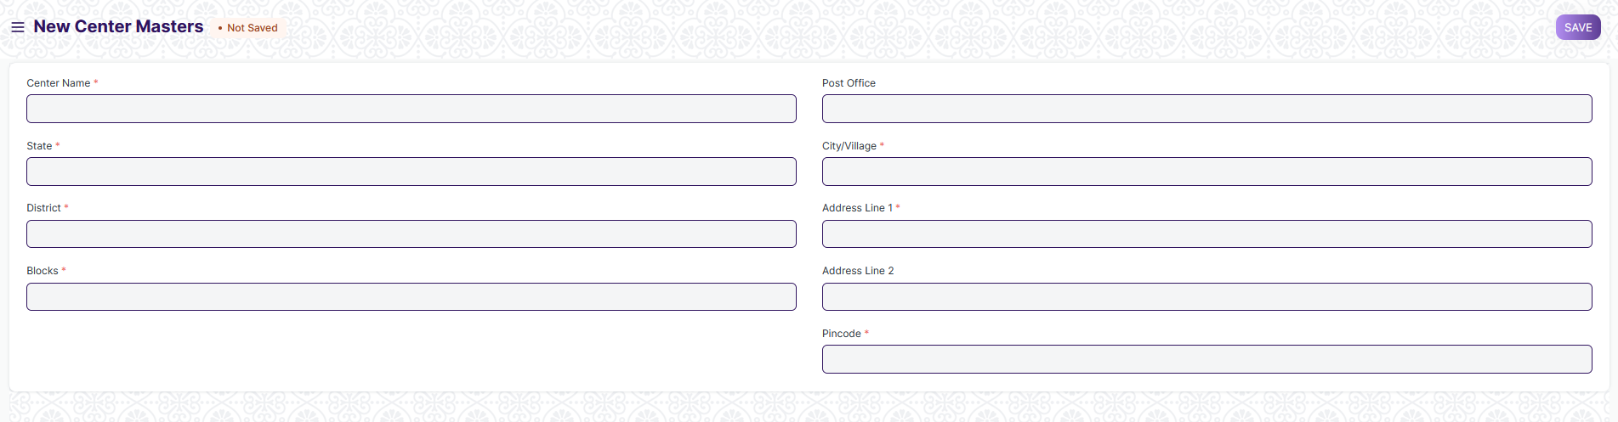

Figure 5: Center Selection Master

**Field List:**

The following table describes the UI fields present in this screen:

|  |  |  |  |  |  |  |
| --- | --- | --- | --- | --- | --- | --- |
| **ID** | **Field Name** | **Field Type** | **Mandatory** | **Validation/Action** | **Remarks** | **R/N/D** |
| 1 | Enable | Checkbox |  |  |  |  |
| 2 | Center Name | Text Field | Yes |  |  |  |
| 3 | States | Link Field | Yes | Links to States Master Screen |  |  |
| 4 | Districts | Link Field | Yes | Links to Districts Master Screen and filtered with respect to State |  |  |
| 5 | Blocks | Link Field | Yes | Links to Blocks Master Screen and filtered with respect to District |  |  |
| 6 | Post Office | Text Field |  |  |  |  |
| 7 | City/Village | Text Field | Yes |  |  |  |
| 8 | Address | Text Field |  |  |  |  |
| 10 | Pincode | Number | Yes |  |  |  |
| 11 | Total Seating Capacity | Number | Yes |  |  |  |

**User: Roles & Permission**

The following table describes the users and their roles and permissions for the screens :

|  |  |  |  |  |  |  |  |  |  |
| --- | --- | --- | --- | --- | --- | --- | --- | --- | --- |
| **ID** | **Role** | **Select** | **Read** | **Write** | **Create** | **Delete** | **Submit** | **Cancel** | **Amend** |
| 1 | Admin | Yes | Yes | Yes | Yes | Yes | NA | NA | NA |
| 2 | Instructor | No | No | No | No | No | NA | NA | NA |
| 3 | Education Admin | Yes | Yes | Yes | Yes | Yes | NA | NA | NA |

## **1.5. Entrance Exam Declaration**

**General Description:**

The following table describe overall information about this screen

|  |  |
| --- | --- |
| **Description :** | * A screen where information regarding exams are stored , like exam date, academic year , term and applicants list |
| **Navigation :** | Home > Admission > Entrance Exam Declaration |
| **Pre-requisites :** | The system should have records in the following screen   1. Academic Year 2. Academic Term 3. Student Applicants |
| **Existing Screen Name** | None |
| **New Screen Name** | Entrance Exam Declaration |

**Screenshots:**

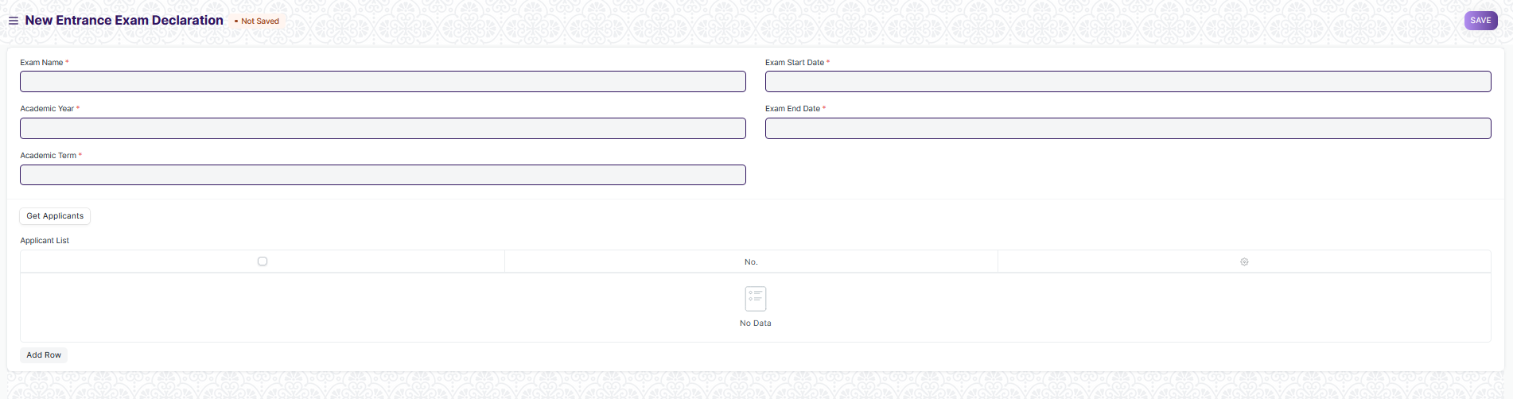

Figure 6: Entrance Exam Declaration

**Field List:**

The following table describes the UI fields present in this screen:

|  |  |  |  |  |  |  |
| --- | --- | --- | --- | --- | --- | --- |
| **ID** | **Field Name** | **Field Type** | **Mandatory** | **Validation/Action** | **Remarks** | **R/N/D** |
| 1 | Exam Name | Text Field | Yes |  |  |  |
| 2 | Academic Year | Link Field | Yes | Links to Academic Year Master Screen |  |  |
| 3 | Academic Term | Link Field | Yes | Links to Academic Term Master Screen |  |  |
| 4 | Exam Start Date | Date | Yes |  |  |  |
| 5 | Exam End Date | Date | Yes |  |  |  |
| 6 | Get Applicants | Button |  |  |  |  |
| 7 | **Applicant List** | Table |  | After Clicking the above button student applicant data will be filled in this table. Also there will be a column in the table called Allotted which will mark if the students have been allotted an exam centre | For further details regarding table Please check below |  |

|  |  |  |  |  |  |  |
| --- | --- | --- | --- | --- | --- | --- |
| **Applicant List** | | | | | | |
| **ID** | **Field Name** | **Field Type** | **Mandatory** | **Validation/Action** | **Remarks** | **R/N/D** |
| 1 | Applicant ID | Link Field | Yes | Links to Student Applicant Screen |  |  |
| 2 | Applicant Name | Text Field | Yes | Data in this field will be filled as per applicant ID | It will be a read only field |  |
| 3 | Gender | Text Field |  | Data in this field will be filled as per applicant ID | It will be a read only field |  |
| 4 | Student Category | Text Field |  | Data in this field will be filled as per applicant ID | It will be a read only field |  |
| 5 | Physical Disability | Check Box |  | It will be check as per data in student applicant | It will be a read only field |  |
| 6 | Center Allocated Status | Check Box |  | This field will be check after admit card generation and student has been allotted an exam centre and an exam date | It will be a read only field |  |

**User: Roles & Permission**

The following table describes the users and their roles and permissions for the screens :

|  |  |  |  |  |  |  |  |  |  |
| --- | --- | --- | --- | --- | --- | --- | --- | --- | --- |
| **ID** | **Role** | **Select** | **Read** | **Write** | **Create** | **Delete** | **Submit** | **Cancel** | **Amend** |
| 1 | Admin | Yes | Yes | Yes | Yes | Yes | NA | NA | NA |
| 2 | Instructor | No | No | No | No | No | NA | NA | NA |
| 3 | Education Admin | Yes | Yes | Yes | Yes | Yes | NA | NA | NA |

## 

## **1.6. Entrance Exam Center Allocation**

**General Description:**

The following table describe overall information about this screen

|  |  |
| --- | --- |
| **Description :** | * A screen where the information regarding exam location and date for the entrance exam is to be allotted and stored |
| **Navigation :** | Home > Admission > Entrance Exam Center Allocation |
| **Pre-requisites :** | The system should have records in the following screen   1. Academic Year 2. Academic Term 3. Student Applicants 4. Center Selection Master 5. Employee |
| **Existing Screen Name** | None |
| **New Screen Name** | Entrance Exam Center Allocation |

**Screenshots:**

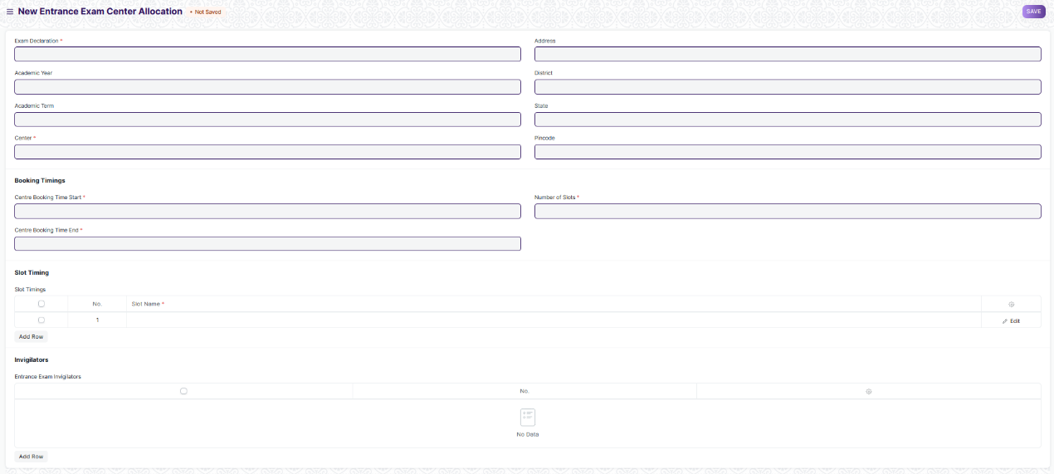

Figure 7: Entrance Exam Center Allocation

**Field List:**

The following table describes the UI fields present in this screen:

|  |  |  |  |  |  |  |
| --- | --- | --- | --- | --- | --- | --- |
| **ID** | **Field Name** | **Field Type** | **Mandatory** | **Validation/Action** | **Remarks** | **R/N/D** |
| 1 | Entrance Exam Declaration | Link Field | Yes | Links to Entrance Exam Declaration Screen |  |  |
| 2 | Academic Year | Text Field |  | Will be filled as per exam declaration selected | Read Only Fields |  |
| 3 | Academic Term | Text Field |  | Will be filled as per exam declaration selected | Read Only Fields |  |
| 4 | Exam Date | Date | Yes | Admin has to enter a date for the exam which would be between exam start and end date , as mention in entrance exam declaration screen |  |  |
| 5 | Centre | Link Field | Yes | Links to Center Selection Master |  |  |
| 6 | Centre Name | Text Field |  | Will be filled as per Center Selection Masters selected | Read Only Fields |  |
| 7 | Address | Text Field |  | Will be filled as per Center Selection Masters selected | Read Only Fields |  |
| 8 | District | Text Field |  | Will be filled as per Center Selection Masters selected | Read Only Fields |  |
| 9 | State | Text Field |  | Will be filled as per Center Selection Masters selected | Read Only Fields |  |
| 10 | Pin Code | Text Field |  | Will be filled as per Center Selection Masters selected | Read Only Fields |  |
| 11 | Centre Booking Time Start | Time | Yes |  |  |  |
| 12 | Centre Booking Time End | Time | Yes |  |  |  |
| **14** | **Exam Slot Timings** | Table | Yes | Will have data regarding exam slots for that specific day. Will need duplicate row validation with respect to exam time | For further details please check the tables below |  |
| **15** | **Entrance Exam Invigilator** | Table | Yes | Contains data of invigilators assigned by WSC |  |  |

|  |  |  |  |  |  |  |
| --- | --- | --- | --- | --- | --- | --- |
| **Exam Slot Timings** | | | | | | |
| **ID** | **Field Name** | **Field Type** | **Mandatory** | **Validation/Action** | **Remarks** | **R/N/D** |
| 1 | Slot Name | Text Field | Yes |  |  |  |
| 2 | Slot Starting Time | Date | Yes |  |  |  |
| 3 | Slot Ending Time | Date | Yes |  |  |  |
| 4 | Seating Capacity | Number | Yes |  |  |  |

|  |  |  |  |  |  |  |
| --- | --- | --- | --- | --- | --- | --- |
| **Entrance Exam Invigilators** | | | | | | |
| **ID** | **Field Name** | **Field Type** | **Mandatory** | **Validation/Action** | **Remarks** | **R/N/D** |
| 1 | Invigilator ID | Link | Yes | Links to Employee Master Screen |  |  |
| 2 | Invigilator Name | Text Field |  | Will be filled as per data from Invigilator ID |  |  |
| 3 | Designation | Text Field |  | Will be filled as per data from Invigilator ID |  |  |

**User: Roles & Permission**

The following table describes the users and their roles and permissions for the screens :

|  |  |  |  |  |  |  |  |  |  |
| --- | --- | --- | --- | --- | --- | --- | --- | --- | --- |
| **ID** | **Role** | **Select** | **Read** | **Write** | **Create** | **Delete** | **Submit** | **Cancel** | **Amend** |
| 1 | Admin | Yes | Yes | Yes | Yes | Yes | Yes | Yes | Yes |
| 2 | Instructor | Yes | Yes | No | No | No | No | No | No |
| 3 | Education Admin | Yes | Yes | Yes | Yes | Yes | Yes | Yes | Yes |

## 

## **1.7. Admit Card Generation Tool**

**General Description:**

The following table describe overall information about this screen

|  |  |
| --- | --- |
| **Description :** | * **A tool to generate multiple admit cards for applicants and also allots them a venue for the exam** |
| **Navigation :** | Home > Admission > Admit Card Generation Tool |
| **Pre-requisites :** | The system should have records in the following screen   1. Academic Year 2. Academic Term 3. Student Applicants 4. Center Selection Master 5. Employee |
| **Existing Screen Name** | None |
| **New Screen Name** | Admit Card Generation Tool |

**Screenshots:**

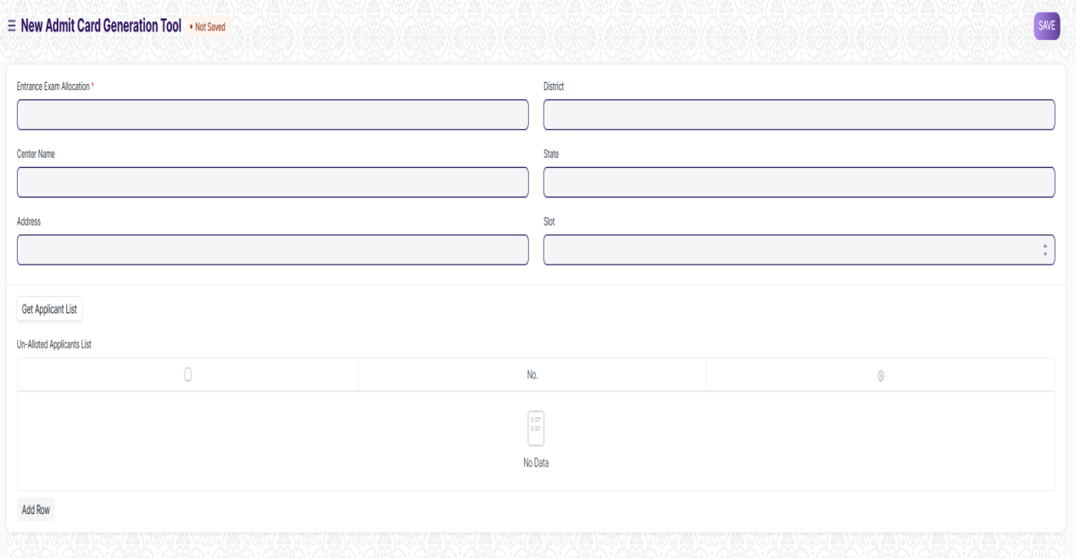

Figure 8: Admit Card Generation Tool

**Field List:**

The following table describes the UI fields present in this screen:

|  |  |  |  |  |  |  |
| --- | --- | --- | --- | --- | --- | --- |
| **ID** | **Field Name** | **Field Type** | **Mandatory** | **Validation/Action** | **Remarks** | **R/N/D** |
| 1 | Entrance Exam Allocation | Link Field | Yes | Links to Entrance Exam Allocation Screen |  |  |
| 2 | Centre Name | Text Field |  | Will be filled as per exam entrance allocation selected | Read Only Fields |  |
| 3 | Address | Text Field |  | Will be filled as per exam entrance allocation selected | Read Only Fields |  |
| 4 | District | Text Field |  | Will be filled as per exam entrance allocation selected | Read Only Fields |  |
| 5 | State | Text Field |  | Will be filled as per exam entrance allocation selected | Read Only Fields |  |
| 6 | Pin code | Text Field |  | Will be filled as per exam entrance allocation selected | Read Only Fields |  |
| 7 | Exam Date | Date |  | Will be filled as per exam entrance allocation selected | Read Only Fields |  |
| 8 | Slot | Dropdown |  | Will be filled as per exam entrance allocation selected. Need to give a validation for slots, when they are filled those slots wont appear in the option |  |  |
| 9 | Get Applicant List | Button |  |  |  |  |
| 10 | **Un-allotted Applicant List** | **Table** |  | After clicking the above button, only those students information will be fetched who haven’t been allocated a venue and exam date | For further details regarding table Please check below |  |

|  |  |  |  |  |  |  |
| --- | --- | --- | --- | --- | --- | --- |
| **Un-Allotted Applicant List** | | | | | | |
| **ID** | **Field Name** | **Field Type** | **Mandatory** | **Validation/Action** | **Remarks** | **R/N/D** |
| 1 | Applicant ID | Link Field | Yes | Links to Student Applicant Screen |  |  |
| 2 | Applicant Name | Text Field | Yes | Data in this field will be filled as per applicant ID | It will be a read only field |  |
| 3 | Gender | Text Field |  | Data in this field will be filled as per applicant ID | It will be a read only field |  |
| 4 | Student Category | Text Field |  | Data in this field will be filled as per applicant ID | It will be a read only field |  |
| 5 | Physical Disability | Check Box |  | It will be check as per data in student applicant | It will be a read only field |  |

**User: Roles & Permission**

The following table describes the users and their roles and permissions for the screens :

|  |  |  |  |  |  |  |  |  |  |
| --- | --- | --- | --- | --- | --- | --- | --- | --- | --- |
| **ID** | **Role** | **Select** | **Read** | **Write** | **Create** | **Delete** | **Submit** | **Cancel** | **Amend** |
| 1 | Admin | Yes | Yes | Yes | Yes | Yes | NA | NA | NA |
| 2 | Instructor | Yes | Yes | No | No | No | NA | NA | NA |
| 3 | Education Admin | Yes | Yes | Yes | Yes | Yes | NA | NA | NA |

## 

## **1.8. Entrance Exam Admit Card**

**General Description:**

The following table describe overall information about this screen

|  |  |
| --- | --- |
| **Description :** | * **A screen which holds information of an individual students admit card** * **Most of the data in this field will be filled by the Admit Card Generation Tool** |
| **Navigation :** | Home > Admission > Entrance Exam Admit Card |
| **Pre-requisites :** | The system should have records in the following screen   1. Student Applicants 2. Center Selection Master |
| **Existing Screen Name** | None |
| **New Screen Name** | Entrance Exam Admit Card |

**Screenshots:**

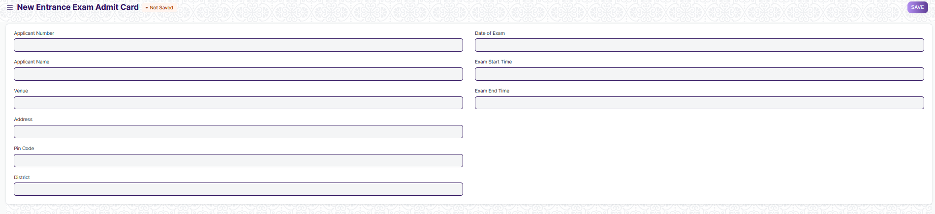

Figure 9: Entrance Exam Admit Card

**Field List:**

The following table describes the UI fields present in this screen:

|  |  |  |  |  |  |  |
| --- | --- | --- | --- | --- | --- | --- |
| **ID** | **Field Name** | **Field Type** | **Mandatory** | **Validation/Action** | **Remarks** | **R/N/D** |
| 1 | Applicant Number | Link Field | Yes | Links to Student Applicant Screen |  |  |
| 2 | Applicant Name | Text Field |  |  |  |  |
| 3 | Address | Text Field |  |  |  |  |
| 4 | Venue | Text Field |  |  |  |  |
| 5 | District | Text Field |  |  |  |  |
| 6 | Pin Code | Text Field |  |  |  |  |
| 7 | Date of Exam | Date |  |  |  |  |
| 8 | Exam Start Time | Time |  |  |  |  |
| 9 | Exam End Time | Time |  |  |  |  |

**User: Roles & Permission**

The following table describes the users and their roles and permissions for the screens :

|  |  |  |  |  |  |  |  |  |  |  |
| --- | --- | --- | --- | --- | --- | --- | --- | --- | --- | --- |
| **ID** | | **Role** | **Select** | **Read** | **Write** | **Create** | **Delete** | **Submit** | **Cancel** | **Amend** |
| 1 | Admin | | Yes | Yes | Yes | Yes | Yes | NA | NA | NA |
| 2 | Instructor | | Yes | Yes | No | No | No | NA | NA | NA |
| 3 | Education Admin | | Yes | Yes | Yes | Yes | Yes | NA | NA | NA |

## **1.9. Entrance Exam Result Publication**

**General Description:**

The following table describe overall information about this screen

|  |  |
| --- | --- |
| **Description :** | * **A screen which contains the marks of an applicant for the entrance exams** |
| **Navigation :** | Home > Admission > Entrance Exam Result Publication |
| **Pre-requisites :** | The system should have records in the following screen   1. Student Applicants 2. Student Admit Card |
| **Existing Screen Name** | None |
| **New Screen Name** | Entrance Exam Result Publication |

**Screenshots:**

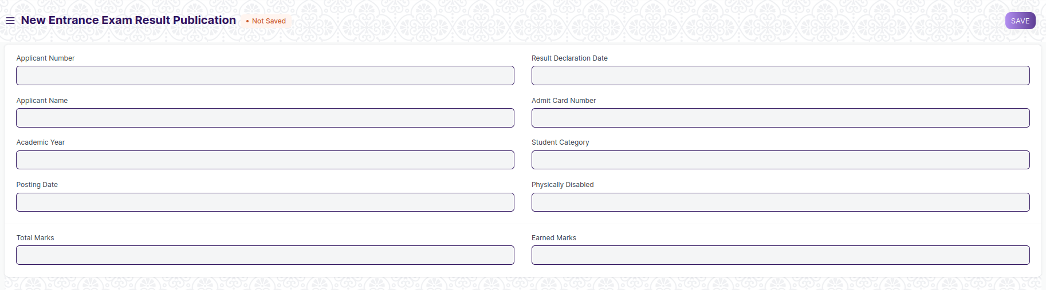

Figure 10: Entrance Exam Result Publication

**Field List:**

The following table describes the UI fields present in this screen:

|  |  |  |  |  |  |  |
| --- | --- | --- | --- | --- | --- | --- |
| **ID** | **Field Name** | **Field Type** | **Mandatory** | **Validation/Action** | **Remarks** | **R/N/D** |
| 1 | Applicant Number | Link Field | Yes | Links to Student Applicant Screen |  |  |
| 2 | Applicant Name | Text Field |  | Will be filled as per student applicant number selected | Read Only Fields |  |
| 3 | Academic Year | Text Field |  | Will be filled as per student applicant number selected | Read Only Fields |  |
| 4 | Result Declaration Date | Date |  |  |  |  |
| 5 | Student Category | Data | Yes | Links to Student Category Master Screen, will be filled as per student applicant data |  |  |
| 6 | Physically Disabled | Checkbox |  |  |  |  |
| 7 | Total Marks | Number |  |  |  |  |
| 8 | Earned Marks | Number |  |  |  |  |

**User: Roles & Permission**

The following table describes the users and their roles and permissions for the screens :

|  |  |  |  |  |  |  |  |  |  |
| --- | --- | --- | --- | --- | --- | --- | --- | --- | --- |
| **ID** | **Role** | **Select** | **Read** | **Write** | **Create** | **Delete** | **Submit** | **Cancel** | **Amend** |
| 1 | Admin | Yes | Yes | Yes | Yes | Yes | NA | NA | NA |
| 2 | Instructor | Yes | Yes | No | No | No | NA | NA | NA |
| 3 | Education Admin | Yes | Yes | Yes | Yes | Yes | NA | NA | NA |

## **1.10. Rank Card Publication Masters**

**General Description:**

The following table describe overall information about this screen:

|  |  |
| --- | --- |
| **Description :** | * **A screen which contains the information regarding an applicants rank obtain in the entrance exam.** * There is a per-determined cutoff for obtaining a rank. If an applicant didn’t clear the cutoff marks, then he/she won’t be provided with a rank |
| **Navigation :** | Home > Admission > Rank Card Publication Masters |
| **Pre-requisites :** | The system should have records in the following screen   1. Student Applicants 2. Student Admit Card |
| **Existing Screen Name** | None |
| **New Screen Name** | Rank Card Publication Masters |

**Screenshots:**

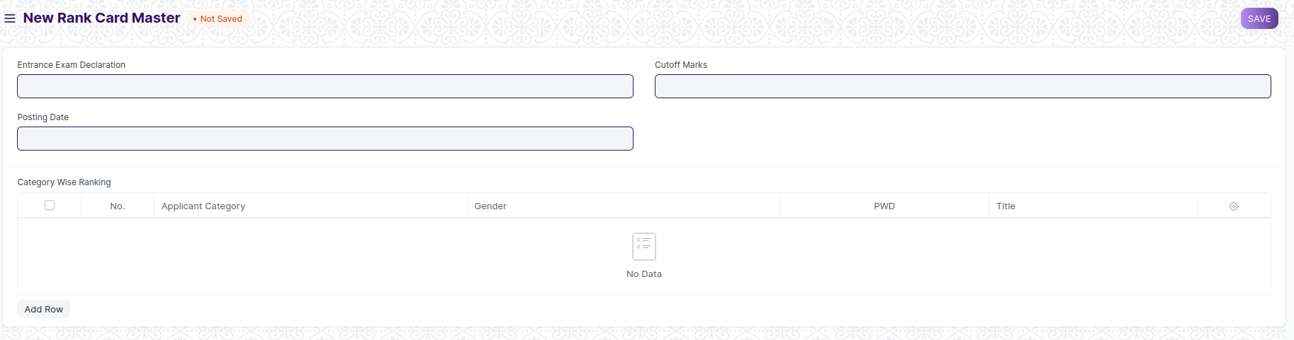

**Field List:**

The following table describes the UI fields present in this screen:

|  |  |  |  |  |  |  |
| --- | --- | --- | --- | --- | --- | --- |
| **ID** | **Field Name** | **Field Type** | **Mandatory** | **Validation/Action** | **Remarks** | **R/N/D** |
| 1 | Entrance Exam Declaration | Link Field | Yes | Links to Entrance Exam Declaration Screen |  |  |
| 2 | Posting Date | Date |  | Will be filled as per Entrance Exam Declaration selected | Read Only Fields |  |
| 3 | Cutoff Marks | Number | Yes |  |  |  |
| 4 | Total Marks | Number | Yes |  |  |  |
| 5 | Academic Year | Text Field |  | Will be filled as per student applicant number selected | Read Only Fields |  |
| 6 | **Category Wise Ranking** | Table |  | Details regarding every ranking category will be filled here |  |  |

|  |  |  |  |  |  |  |
| --- | --- | --- | --- | --- | --- | --- |
| **Student Rank List** | | | | | | |
| **ID** | **Field Name** | **Field Type** | **Mandatory** | **Validation/Action** | **Remarks** | **R/N/D** |
| 1 | Student Category | Link Field | Yes | Links to Student Category Master Screen |  |  |
| 2 | Gender | Link Field | Yes | Links to Gender Master Screen |  |  |
| 3 | PWD | Checkbox |  |  |  |  |
| 4 | Tittle | Text Field |  |  |  |  |

**User: Roles & Permission**

The following table describes the users and their roles and permissions for the screens :

|  |  |  |  |  |  |  |  |  |  |
| --- | --- | --- | --- | --- | --- | --- | --- | --- | --- |
| **ID** | **Role** | **Select** | **Read** | **Write** | **Create** | **Delete** | **Submit** | **Cancel** | **Amend** |
| 1 | Admin | Yes | Yes | Yes | Yes | Yes | NA | NA | NA |
| 2 | Instructor | Yes | Yes | No | No | No | NA | NA | NA |
| 3 | Education Admin | Yes | Yes | Yes | Yes | Yes | NA | NA | NA |

## **1.11. Rank Card**

**General Description:**

The following table describe overall information about this screen:

|  |  |
| --- | --- |
| **Description :** | * **A screen which contains the information regarding an applicants rank obtain in the entrance exam.** * There is a per-determined cutoff for obtaining a rank. If an applicant didn’t clear the cutoff marks, then he/she won’t be provided with a rank * Data in this screen will be filled as via Rank Publication Tool |
| **Navigation :** | Home > Admission > Rank Card |
| **Pre-requisites :** | The system should have records in the following screen   1. Student Applicants 2. Student Admit Card 3. Exam Declaration |
| **Existing Screen Name** | None |
| **New Screen Name** | Rank Card |

**Screenshots:**

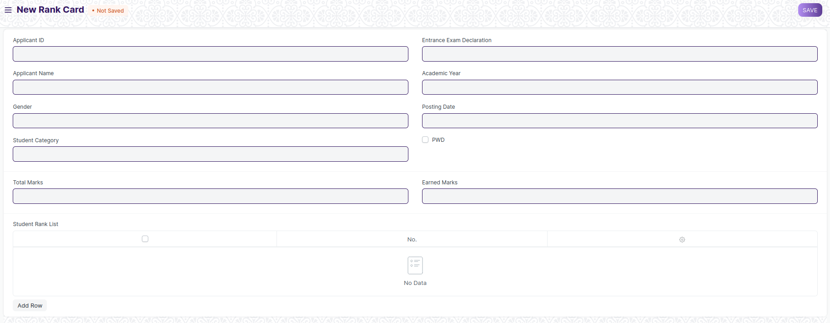

Figure 11: Rank Card

**Field List:**

The following table describes the UI fields present in this screen:

|  |  |  |  |  |  |  |
| --- | --- | --- | --- | --- | --- | --- |
| **ID** | **Field Name** | **Field Type** | **Mandatory** | **Validation/Action** | **Remarks** | **R/N/D** |
| 1 | Applicant ID | Link Field | Yes | Links to Student Applicant Screen |  |  |
| 2 | Applicant Name | Text Field | Yes | Will be filled as per student applicant number selected | Read Only Fields |  |
| 3 | Gender | Link Field | Yes | Will be filled as per student applicant number selected | Read Only Fields |  |
| 4 | Student Category | Link Field | Yes | Will be filled as per student applicant number selected | Read Only Fields |  |
| 5 | Entrance Exam Declaration | Link Field | Yes | Links to Entrance Exam Declaration Screen |  |  |
| 6 | Academic Year | Text Field |  | Will be filled as per student applicant number selected | Read Only Fields |  |
| 7 | Posting Date | Date |  |  |  |  |
| 9 | Physically Disabled | Checkbox |  | Will be filled as per student applicant number selected | Read Only Fields |  |
| 9 | Total Marks | Number |  |  |  |  |
| 10 | Earned Marks | Number |  | Will be filled as per the rank card publication tool |  |  |
| 11 | **Student Ranks List** | Table |  | Label for the fields will be fetch as per Rank Card Publication Masters. Current ones seen are generic and need to get the rank categories from WSC |  |  |

|  |  |  |  |  |  |  |
| --- | --- | --- | --- | --- | --- | --- |
| **Student Rank List** | | | | | | |
| **ID** | **Field Name** | **Field Type** | **Mandatory** | **Validation/Action** | **Remarks** | **R/N/D** |
| 1 | General Rank | Number |  |  | After rank card distribution, applicants Ranks will be visible here |  |
| 2 | Category Based Rank | Number |  |  | After rank card distribution, applicants Ranks will be visible here |  |
| 3 | PWD Based Rank | Number |  |  | After rank card distribution, applicants Ranks will be visible here |  |

**User: Roles & Permission**

The following table describes the users and their roles and permissions for the screens :

|  |  |  |  |  |  |  |  |  |  |
| --- | --- | --- | --- | --- | --- | --- | --- | --- | --- |
| **ID** | **Role** | **Select** | **Read** | **Write** | **Create** | **Delete** | **Submit** | **Cancel** | **Amend** |
| 1 | Admin | Yes | Yes | Yes | Yes | Yes | NA | NA | NA |
| 2 | Instructor | Yes | Yes | No | No | No | NA | NA | NA |
| 3 | Education Admin | Yes | Yes | Yes | Yes | Yes | NA | NA | NA |

## **1.12. Rank Card Publication Tool**

**General Description:**

The following table describe overall information about this screen:

|  |  |
| --- | --- |
| **Description :** | * **A screen which used to make large number of rank card** |
| **Navigation :** | Home > Admission > Rank Card Publication Tool |
| **Pre-requisites :** | The system should have records in the following screen   1. Entrance Exam Declaration 2. Student Applicant |
| **Existing Screen Name** | None |
| **New Screen Name** | Rank Card Publication Tool |

**Screenshots:**

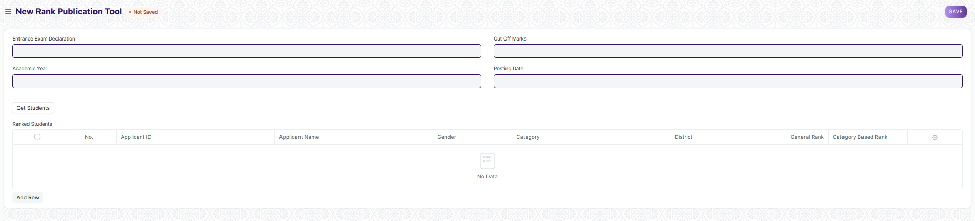

Figure 12: Rank Publication Tool

**Field List:**

The following table describes the UI fields present in this screen:

|  |  |  |  |  |  |  |
| --- | --- | --- | --- | --- | --- | --- |
| **ID** | **Field Name** | **Field Type** | **Mandatory** | **Validation/Action** | **Remarks** | **R/N/D** |
| 1 | Entrance Exam Declaration | Link Field | Yes | Links to Entrance Exam Declaration Screen |  |  |
| 2 | Academic Year | Text Field |  | Will be filled as per Entrance Exam Declaration selected | Read Only Fields |  |
| 3 | Cut Off Marks | Number |  |  |  |  |
| 4 | Total Marks | Number |  |  |  |  |
| 5 | Posting Date | Date |  |  |  |  |
| 6 | Get Students | Button |  |  |  |  |
| 7 | **Ranked Students** | Table | Yes | Will be filled with students data ,who have scored above the cutoff marks and will be sorted as per General Rank and category based ranks | For further details regarding table Please check below |  |

|  |  |  |  |  |  |  |
| --- | --- | --- | --- | --- | --- | --- |
| **Ranked Students List** | | | | | | |
| **ID** | **Field Name** | **Field Type** | **Mandatory** | **Validation/Action** | **Remarks** | **R/N/D** |
| 1 | Applicant ID | Link Field | Yes | Links to Student Applicant Screen |  |  |
| 2 | Applicant Name | Text Field | Yes | Data in this field will be filled as per applicant ID | It will be a read only field |  |
| 3 | Gender | Text Field |  | Data in this field will be filled as per applicant ID | It will be a read only field |  |
| 4 | Student Category | Text Field |  | Data in this field will be filled as per applicant ID | It will be a read only field |  |
| 5 | Physical Disability | Check Box |  | It will be check as per data in student applicant | It will be a read only field |  |
| 6 | General Rank | Number |  | Will sorted as per data from entrance exam evaluation |  |  |
| 7 | Category Based Rank | Number |  | Will sorted as per data from entrance exam evaluation |  |  |

**User: Roles & Permission**

The following table describes the users and their roles and permissions for the screens :

|  |  |  |  |  |  |  |  |  |  |
| --- | --- | --- | --- | --- | --- | --- | --- | --- | --- |
| **ID** | **Role** | **Select** | **Read** | **Write** | **Create** | **Delete** | **Submit** | **Cancel** | **Amend** |
| 1 | Admin | Yes | Yes | Yes | Yes | Yes | NA | NA | NA |
| 2 | Instructor | Yes | Yes | No | No | No | NA | NA | NA |
| 3 | Education Admin | Yes | Yes | Yes | Yes | Yes | NA | NA | NA |

## **1.13. Program Enrolment**

**General Description:**

The following table describe overall information about this screen:

|  |  |
| --- | --- |
| **Description :** | * **A screen which is used to enroll students with their selected subject** |
| **Navigation :** | Home > Admission > Application and Enrollment > Program Enrollment |
| **Pre-requisites :** | The system should have records in the following screen   1. Student Applicant 2. Entrance Exam Evaluation 3. Rank Card Publication 4. Semester 5. Academic Year 6. Academic Term |
| **Existing Screen Name** | Program Enrolment |
| **New Screen Name** | Course Enrollment |

**Screenshots:**

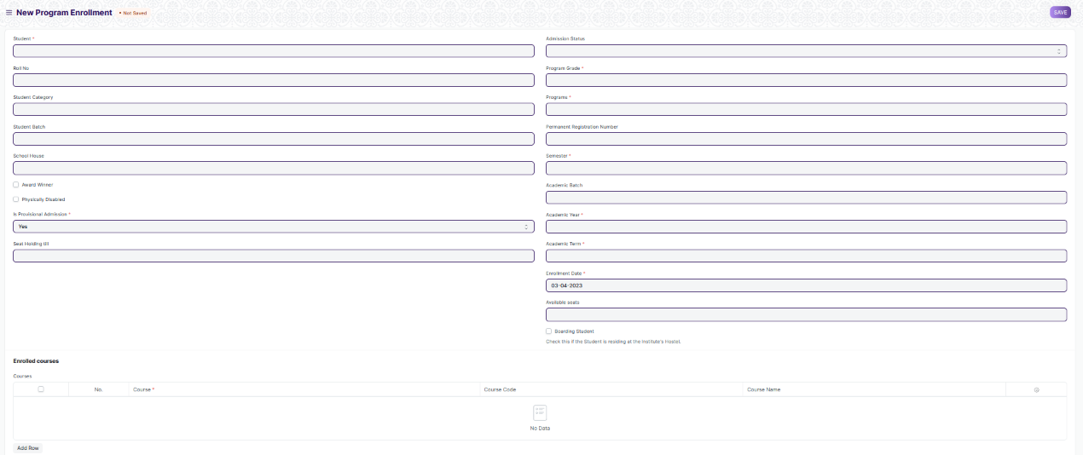

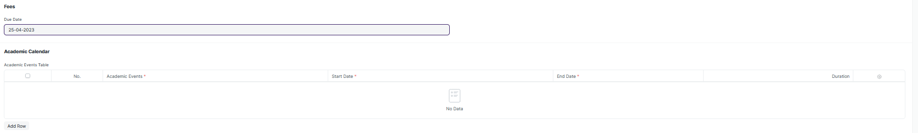

Figure 13: Program Enrollment

**Field List:**

The following table describes the UI fields present in this screen:

|  |  |  |  |  |  |  |
| --- | --- | --- | --- | --- | --- | --- |
| **ID** | **Field Name** | **Field Type** | **Mandatory** | **Validation/ Action** | **Remarks** | **R/N/D** |
| 1 | Applicant ID | Link Field | Yes | Links to Student Applicant Screen |  |  |
| 2 | Applicant Name | Text Field |  | Will be Filled as per Student Applicant | Read Only |  |
| 3 | Roll Number | Number | Yes | This field is to be either generate as per syntax given by WSC or needs to filled manually |  |  |
| 4 | Gender | Link Field | Yes | Links to Master Screen Gender |  |  |
| 5 | Academic Year | Link Field | Yes | Links to Master Screen Academic Year |  |  |
| 6 | Academic Term | Link Field | Yes | Links to Master Screen Academic Term |  |  |
| 7 | Student Category | Link Field | Yes | Links to Master Student Category |  |  |
| 8 | Physically Disabled | Checkbox |  |  |  |  |
| 9 | **Disable Type** | Table |  | Appears Only if Physical Disability Checkbox is clicked | For further details regarding table Please check below |  |
| 10 | Award Winner | Checkbox |  |  |  |  |
| 10 | **Awards List** | Table |  | Appears only if Award Winner Required Checkbox is clicked | For further details regarding table Please check below |  |
| 11 | Is provisional Admission | Dropdown |  | Options are Yes and No |  |  |
| 14 | Admission Status | Dropdown |  | Provisional Admission  Admitted |  |  |
| 12 | Seat Holding Till | Date |  |  |  |  |
| 13 | Programs | Link Field | Yes | Links to Programs Master Screen |  |  |
| 14 | Semester | Link Field | Yes | Links to Semesters Master Screen |  |  |
| 15 | Department | Link Field | Yes | Link to Department |  |  |
| 16 | Enrolment Date | Date | Yes |  |  |  |
| 17 | Seat Reservation Type | Link Field |  | Links to Seat Reservation Type |  |  |
| 18 | Available Seats | Number |  | No. of seats available is based on seat reservation type selected |  |  |
| 19 | Boarding Students | Checkbox |  |  |  |  |
| 20 | Courses | Table |  |  | For further details regarding table Please check below |  |
| 21 | **Fees** | Table |  |  | For further details regarding table Please check below |  |
| 22 | Due Date | Date |  |  |  |  |
| 23 | **Academic Events Table** | Table |  |  | For further details regarding table Please check below |  |

|  |  |  |  |  |  |  |
| --- | --- | --- | --- | --- | --- | --- |
| **Awards List** | | | | | | |
| **ID** | **Field Name** | **Field Type** | **Mandatory** | **Validation/Action** | **Remarks** | **R/N/D** |
| 1 | Awards | Link Field | Yes | Link Fields to screen Awards |  |  |
| 2 | Won In Year | Text | Yes |  |  |  |

|  |  |  |  |  |  |  |
| --- | --- | --- | --- | --- | --- | --- |
| **Physically Disabled** | | | | | | |
| **ID** | **Field Name** | **Field Type** | **Mandatory** | **Validation/Action** | **Remarks** | **R/N/D** |
| 1 | Disability Type | Text | Yes |  |  |  |
| 2 | Percentage of Disability | Percent | Yes |  |  |  |
| 3 | Attach Disability Certificate | Attach | Yes |  |  |  |

|  |  |  |  |  |  |  |
| --- | --- | --- | --- | --- | --- | --- |
| **Program Enrollment Course** | | | | | |  |
| **ID** | **Field Name** | **Field Type** | **Mandatory** | **Validation/Action** | **Remarks** | **R/N/D** |
| 1 | Course | Link Field | Yes | Link Fields to master screen Course | ( R ) Module |  |
| 2 | Course Code | Text |  |  | ( R ) Module Code |  |
| 3 | Course Name | Text |  |  | ( R ) Module Name |  |
| 4 | Instructor | Link Field |  | Link Fields to master screen Instructor | ( R ) Trainer |  |
| 5 | Credit Allocation | Button |  |  |  |  |

|  |  |  |  |  |  |  |
| --- | --- | --- | --- | --- | --- | --- |
| **Program Fee** | | | | |  |  |
| **ID** | **Field Name** | **Field Type** | **Mandatory** | **Validation/Action** | **Remarks** | **R/N/D** |
| 1 | Academic Term | Link Field |  | Link Fields to master screen Academic Term |  |  |
| 3 | Fee Structure | Link Field | Yes | Link Fields to master screen Fee Structure |  |  |
| 5 | Student Category | Link Field |  | Link Fields to master screen Student Category |  |  |
| 7 | Due Date | Date |  |  |  |  |
| 9 | Amount | Currency |  |  |  |  |

|  |  |  |  |  |  |  |
| --- | --- | --- | --- | --- | --- | --- |
| **Fee Structure Item** | | | | | | |
| **ID** | **Field Name** | **Field Type** | **Mandatory** | **Validation/Action** | **Remarks** | **R/N/D** |
| 1 | Student Category | Link Field |  | Link Fields to master screen Student Category |  |  |
| 2 | Fee Structure | Link Field | Yes | Link Fields to master screen Fee Structure |  |  |
| 3 | Amount | Currency |  |  |  |  |
| 4 | Due Date | Date | Yes |  |  |  |

|  |  |  |  |  |  |  |
| --- | --- | --- | --- | --- | --- | --- |
| **Admission Fees** | | | | | | |
| **ID** | **Field Name** | **Field Type** | **Mandatory** | **Validation/Action** | **Remarks** | **R/N/D** |
| 1 | Academic Events | Link Field | Yes | Link Fields to master screen Academic Events |  |  |
| 2 | Start Date | Date | Yes |  |  |  |
| 3 | End Date | Date | Yes |  |  |  |
| 4 | Duration | Number |  |  |  |  |

|  |  |  |  |  |  |  |
| --- | --- | --- | --- | --- | --- | --- |
| **Academic Events Table** | | | | | | |
| **ID** | **Field Name** | **Field Type** | **Mandatory** | **Validation/Action** | **Remarks** | **R/N/D** |
| 1 | Academic Events | Link Field | Yes | Link Fields to master screen Academic Events |  |  |
| 2 | Start Date | Date | Yes |  |  |  |
| 3 | End Date | Date | Yes |  |  |  |
| 4 | Duration | Number |  |  |  |  |

**User: Roles & Permission**

The following table describes the users and their roles and permissions for the screens :

|  |  |  |  |  |  |  |  |  |  |
| --- | --- | --- | --- | --- | --- | --- | --- | --- | --- |
| **ID** | **Role** | **Select** | **Read** | **Write** | **Create** | **Delete** | **Submit** | **Cancel** | **Amend** |
| 1 | Admin | Yes | Yes | Yes | Yes | Yes | NA | NA | NA |
| 2 | Instructor | Yes | Yes | No | No | No | NA | NA | NA |
| 3 | Education Admin | Yes | Yes | Yes | Yes | Yes | NA | NA | NA |